Naginata Shodan Test
Kamae
- Chudon no kamae
- Jodan no kamae
- Gedan no kamae
- Wakigamae
- Hasso no kamae
- Mugamae
Valid datosu-bui (striking points)
- Shomen
- Soku-men (left & right)
- Do (left & right)
- Throat
- Inside & Outside Sune (left & right)
- Kote (left & right)
Parts of the Naginata
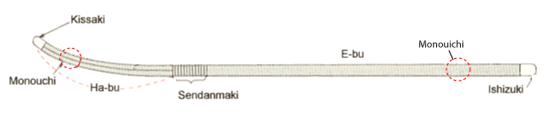
Extra Questions
Two types of competition
- Shiai competition
  - bogu is worn
  - try to hit your opponent on a valid datosu-bui
  - while avoiding being hit
  - competition continues until someone meets the victory conditions (e.g., two valid strikes) or time runs out

- Engi competition
  - Movements are pre-arranged
  - Either shikaki-oji competition or Zen Nihon kata competition
  - Winner is pair that is judged to have the best skill
Chudan no Kamae
- fundamental of all kamaes
- body is turned to the side
- kissaki covers the center of the body and is aimed at the misouchi of the opponent
- arms extended
- distance between arms = distance between feet
- distance between feet = 1.5 - 2x length of foot
- rear hand should grasp the naginata about at forearms length from the ishizuki
- rare hand must lightly touch the inner thigh of rear leg
- spirit filled with energy
Names of the footwork
- Okuri-ashi
- Ayumi-ashi
- Hiraki-ashi
- Famikae-ashi
- Tsugi-ashi
What is Ma-ai ga Chigai? (close distance)
- Mai-ai is the distance between you and your opponent
- correct distance = 1 step forward to hit your opponent & 1 step backward to avoid being hit
- ma-ai ga chigai is a mai-ai that is closer than the correct ma-ai
- if you can't keep ma-ai and you get too close, you are easier to hit
Distance between starting lines in Engi and Shiai
4m in both Engi and Shiai

